*10 Affordable and Natural Do-It-Yourself Beauty Tricks*

If you’re looking for environmentally friendly natural beauty methods that don’t cost a bundle, we have good news: You can treat yourself from head to toe with stuff that you’ve probably already got in your kitchen. Here are 15 couldn’t-be-easier beauty hacks that are 100 percent natural and totally affordable.

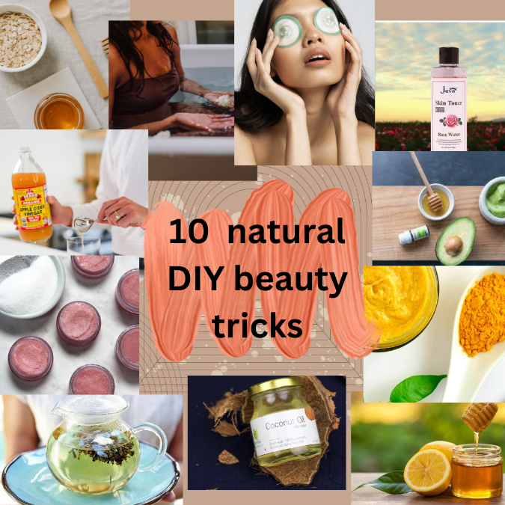

1. **Coconut Oil Hair Mask**: Apply coconut oil to your hair and leave it in for at least an hour,or overnight if possible. Wash it out with shampoo and conditioner for soft, shiny locks.

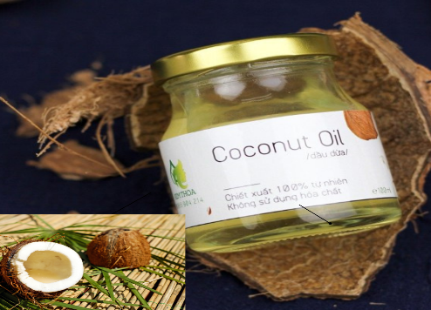

1. **Baking Soda Exfoliant**: Mix baking soda with water to create a paste and gently massage it onto your skin in circular motions. Rinse off with warm water for smooth, glowing skin.

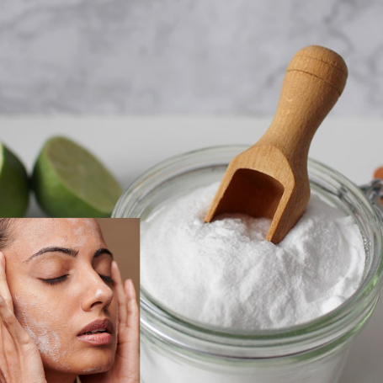

1. **Lemon Juice Toner**: Apply freshly squeezed lemon juice to your face with a cotton ball and leave it on for a few minutes before rinsing off with water. The citric acid in the lemon juice helps to brighten and tone the skin.

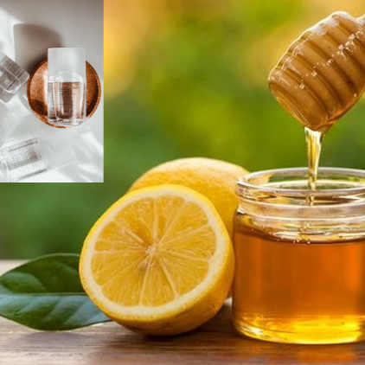

1. **Apple Cider Vinegar Hair Rinse**: Mix equal parts apple cider vinegar and water and use it as a final rinse after shampooing and conditioning your hair.

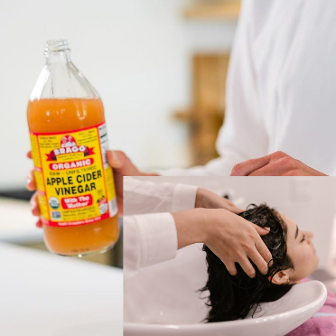

1. **Honey Face Mask**: Apply raw honey to your face and leave it on for 15-20 minutes before rinsing off with warm water. Honey is a natural humectant that moisturizes and soothes the skin.

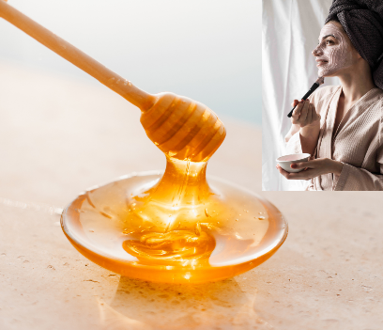

1. **Green Tea Facial Steam**: Brew a pot of green tea and pour it into a bowl. Lean over the bowl and cover your head with a towel to create a steam tent. Breathe in the steam for 5-10 minutes to open up your pores and detoxify your skin.

1. **Oatmeal Bath Soak**: Add a cup of uncooked oats to your bath and soak for 20-30 minutes. Oatmeal is a natural skin soother that helps to relieve dry, itchy skin.

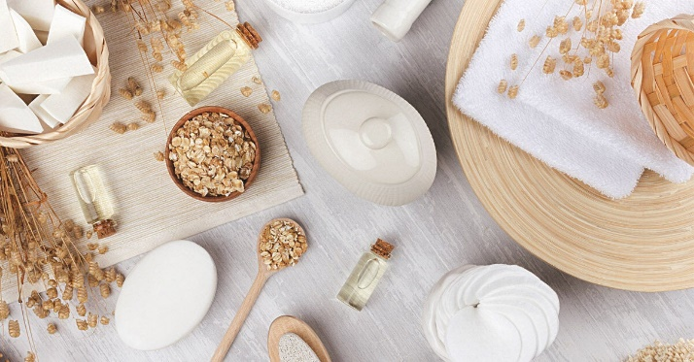

1. **Avocado Hair Mask**: Mash half an avocado and mix it with a tablespoon of olive oil. Apply the mixture to your hair and leave it in for 20-30 minutes before rinsing out with shampoo and conditioner. Avocado is rich in healthy fats that help to nourish and strengthen the hair.

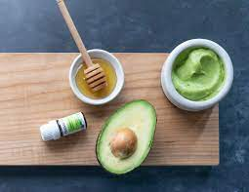

1. **Sugar Lip Scrub**: Mix equal parts brown sugar and coconut oil and gently massage it onto your lips in circular motions. Rinse off with warm water for soft, smooth lips.

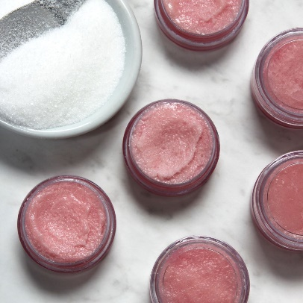

1. **Aloe Vera Face Mask**: Mix aloe vera gel with a few drops of lemon juice and apply to your face. Leave it on for 10-15 minutes before rinsing off with warm water. Aloe vera is known for its anti-inflammatory and moisturizing properties.

